Pre-Course Writing Test
Name:
Date:

SECTION A: Sentence Accuracy & Micro-Writing /

Task Al. Error Correction (10 points total)

Rewrite each sentence below in correct, professional English. Each item is worth 2 points. / 2 kc
o
- Thank you for your email. I am checking the matter but need more informations from colleague.

- The attached file is not same version that we discussed in last meeting.

Task A2. Micro-Writing (15 points total)

Write 1-2 professionally appropriate sentences for each prompt. Each item is worth 5 points. / e

5 kC30
- Inform a foreign counterpart that you need two extra days to prepare a response. /
2

- Request clarification about a contradictory section of an international guideline. /
in The
Etion

SECTION B: Task-Based Writing /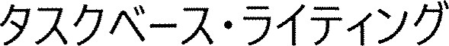
Task Bl. Email to a Foreign Office (25 points)

Write a 120-160 word email to an EPO officer requesting clarification about a difference in document submission requirements. This task is worth 25 points. /
EPO
25 kC30
Include / :
- Purpose of inquiry / fi

Short background /
Specific questions /
- Deadline /
Professional tone /

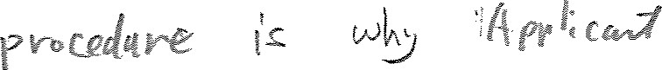
Dec

Task B2. Administrative Explanation (25 points)

Write a 100-130 word internal explanation describing a new step added to an administrative process for handling foreign applicants. /
(100—130 =nä)
Include /  :
- What changed /
- Why it matters / 
- What staff should do /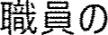
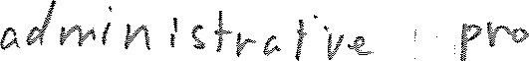Cez
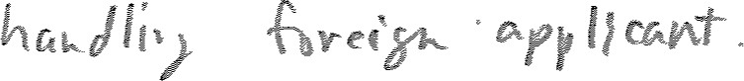

6
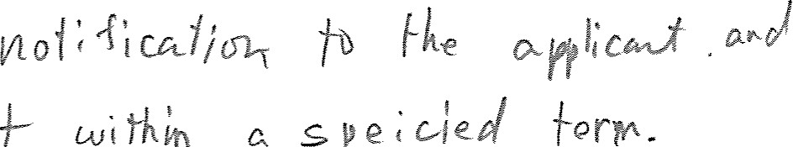
so-A 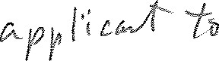cub
fpm
SECTION C: Revision & Editing /

Task Cl. Rewriting (25 points)

Rewrite the email below to make it clear, professional, and logically structured. /
Dear colleague,
I reviewed your draft but several parts were unclear, and I was not able to understand the procedure.
The applicant has already contacted us twice, and we have not been able to respond because we do not yet have an accurate explanation. Please review the instructions again and provide the correct procedure as soon as possible, as the deadline is approaching.
Thank you.


